# 1.Bluetooth Development Process：

This process is used for customers who do not call aar development and develop by themselves；

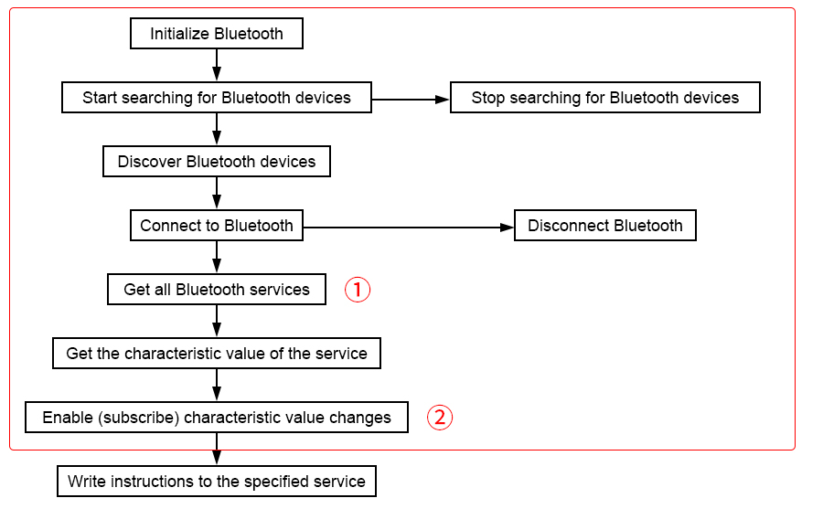

①Get all Bluetooth services, then find the following service and get the characteristic value of the service

Service：0000fe0-0000-1000-8000-00805f9b34fb

②Enable (subscribe to) the following characteristic value changes

write：0000fe3-0000-1000-8000-00805f9b34fb

notify：0000fe4-0000-1000-8000-00805f9b34fb

# 2.Instructions for using buttons, mode switching, and reporting format：

1.When a key is pressed, the key press information will be uploaded first (refer to the user manual command RFM_REPORT_KEYSTA)

2.Then upload the tag information (refer to the user manual command RFM_INVENTORYISO_CONTINUE)

3.Then upload the tag information (refer to the user manual command RFM_INVENTORYISO_CONTINUE)

4.The barcode reporting format is as follows

HEAD：CF（Head, fixed）

ADDR：00（Device address, usually 00）

CMD：0001（Instructions, fixed）

LEN：1byte（length）

STATUS：1byte（Status, only 0 is successful）

RSSI：2byte（Not applicable, returns 0000）

ANT：1byte（Not applicable, returns 00）

CHANNEL ：1byte（Not applicable, returns 00）

DATA_LEN ：1byte（Barcode length）

DATA ：The length of Nbyte (barcode) is determined by DATA_LEN. The first byte is fixed to 02, the last 2 bytes are fixed to 030D, and the middle is the barcode data in ASCII format.

CHECK：2byte（Check code）

1. RFID reporting format is as follows

HEAD: CF (header, fixed)

ADDR: 00 (device address, usually 00)

CMD: 0001 (command, fixed)

LEN: 1byte (length)

STATUS: 1byte (status, only 00 is successful)

RSSI: 2byte (response RSSI, signed, negative, using complement format) FE C0 means -32dbm

ANT: 1byte (antenna) bit0 means antenna 1, bit1 means antenna 2, and so on

CHANNEL: 1byte (channel) starts from 0, 0 means channel 0, 1 means channel 1, and so on

DATA_LEN: 1byte (label length)

DATA: Nbyte (label) length is determined by DATA_LEN

CHECK: 2byte (check code)